Zaha Hadid's RIBA award angers Chinese heritage group
1 August 2013 | By David Rogers
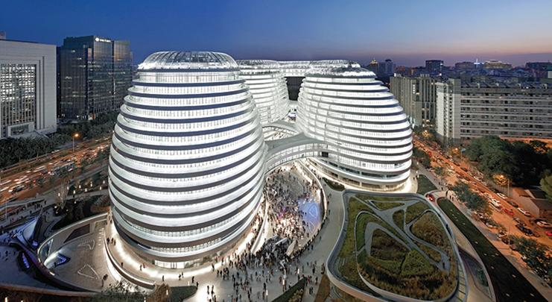
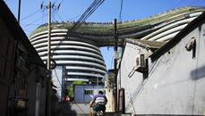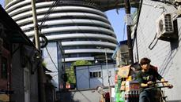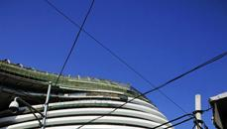
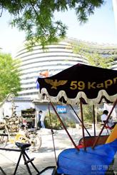

Related Articles
- Don’t sweep away Beijing’s past
1 August 2013
- In pictures: RIBA National Awards 2013
13 June 2013
- Zaha Hadid's Galaxy Soho takes off
30 October 2012
Culture centre calls decision “shocking”
A Chinese heritage group has written to the RIBA blasting the decision to give Zaha Hadid’s Galaxy Soho office and retail scheme in Beijing a RIBA award.
In the letter, the Beijing Cultural Heritage Protection Centre said it was “shocked” the project, which has also been nominated for the RIBA Lubetkin Prize, had been recognised with a RIBA international award this year.
“The Galaxy Soho project has violated a number of heritage preservation laws and regulations,” the letter said. “It has caused great damage to the preservation of the old Beijing streetscape, the original urban plan, the traditional Hutong and courtyard houses.”
It said the scheme was a “typical unfortunate example on the destruction of Beijing old town” and complained that by giving it an award the RIBA was “encouraging” developers to carry on with the “destruction of cultural heritage sites”.
It added: “Many of us in Beijing are very disappointed and offended. We strongly believe this award by your institution will encourage developers and authorities to continue to commit the wrongs they have done and will increase the difficulties of cultural heritage preservation in China.”
A spokesman for the centre told BD: “There are a lot of architects ignoring Chinese cultural heritage when they design.”
A RIBA spokesman said it had received the letter and would be replying to the group to formally acknowledge it but declined to comment further.
Announcing the three-strong shortlist for the Lubetkin Prize last month, RIBA president Angela Brady called Galaxy Soho “impressive” and said: “These [three] cutting-edge schemes show the leading role architects play in delivering visionary new thinking about urban issues.”
The Galaxy Soho scheme is characterised by four towers clad in flowing bands of white aluminium and glass and was completed last October. It is Hadid’s first shopping centre scheme.
The architect declined to comment but a spokesman said it would pass the letter on to its client, Soho China.
Prince’s Foundation special adviser Hank Dittmar said the letter had raised a number of important issues. “Politicians and developers [are] seeking to position their metropolis or their project in the global economy by hiring a famous architect who has attracted attention to another city. The result is a succession of cities becoming architectural trophy rooms with every city collecting its own Hadid, Nouvel, Eisenmann or Rogers.”
And he added: “Addressing the lowest common denominator effect by reflecting what was destroyed in the abstract, either formally as in Galaxy Soho’s courtyards, or through interpretation, is merely writing an obituary, not keeping the culture alive.”

